Effects of Companion Cropping and Fall Grazing on Winter Canola

J. Holman, T. Roberts, S. Maxwell, and M. Stamm

Summary
Winter canola (Brassica napus L.) is a relatively new crop to be grown in the southern Great Plains and is being grown in place of winter wheat within the crop rotation. Establishment and winter survival are challenges of growing winter canola in the region. Management practices were identified that improved establishment, winter survival, and grain yield (Holman et al., 2011), but information is still needed on how to best grow winter canola in the region.

Canola varieties Griffin and Wichita were grown with and without a companion crop (spring triticale, winter triticale, Daikon radish, and Shogoin turnip) and were managed with and without fall simulated grazing (hay). Treatment effects (variety, companion crop, and fall grazing) on winter canola fall plant density, fall vigor, winter survival, spring plant density, spring vigor, grain yield, forage yield, forage quality, and grain oil content were quantified.

Grazing or haying canola in the fall reduced grain yield 30–50% and decreased the yield of a more upright growth variety (Wichita) more than a prostate growth variety (Griffin). Companion cropping decreased canola fall stand, winter survival, spring stand, and grain yield. Companion crops can improve fall forage production. The results from this study indicate canola grown for grain should not be grown with a companion crop or in a dual-purpose system.

Introduction
Growing a companion crop or grazing canola in the fall might affect winter survival and grain yield of canola, but it might also provide more options and economic incentive to growing the crop if winter survival or forage production are increased. This study evaluated the effects of companion cropping and fall grazing on winter canola survival, forage yield, and grain yield.

The southern Great Plains has sufficient growing degree days to produce 120 to 150 days of grazable wheat pasture that can be either grazed out in the spring or harvested for grain after grazing in a dual-purpose system. Producing winter wheat in a dual-purpose system is a unique and economically important resource. Winter wheat provides economical, high-quality forage at a time of the year when few other quality forage sources are available. It is estimated that 3.2 million ha (7.9 million acres) of winter wheat in the southern Great Plains are grazed annually in a dual-purpose system (Carver et al., 2001). Winter wheat that
is harvested for grain can be grazed in the late fall and early spring without reducing grain production as long as cattle are removed before wheat development reaches first hollow stem, soil moisture is adequate, and recommended growing
practices are implemented (Khalil et al., 2002; Redmon et al., 1996; Virgona et al., 2006). Grazing occasionally increased yield of tall winter wheat varieties by reducing plant height, which resulted in less plant lodging (Redmon et al., 1995). Insufficient information is available on the effects of grazing canola, yet producers need this information. Previous research found companion-cropping winter annual legumes with winter triticale increased survival of the winter legume. Growing a companion crop with winter canola might affect its winter survival and forage yield.

Procedures
Field studies were conducted at the Kansas State University Southwest Research-Extension Center in Garden City, KS (37°59’7”N, 100°48’52”W, elevation 2,862 ft). Average annual precipitation was 19.3 in. Soil type was a Ulysses silt loam soil (fine-silty, mixed, superactive, mesic Aridic Haplustolls) with pH 7.8 and 1.8% organic matter in the top 6 in. of soil.

The experimental design was a randomized split-plot with four replications. Main plot treatment was canola variety (Griffin or Wichita) and companion crop treatment (none, spring triticale, winter triticale, radish, and turnip), and split-plot treatment was managed with or without simulated fall grazing (haying). Winter canola was planted in the fall on August 30, 2010, and September 6, 2011, into a conventional-tillage seedbed. Wheat was grown preceding canola in 2010, and corn was grown preceding canola in 2011. Both Griffin and Wichita were planted at 5 lb/a, 0.75 in. deep, using a double disk opener and fluted coulter with 8-in. row spacing. Companion crops were planted with canola in 2010. In 2011, canola and cover crops were planted in alternate 8-in. rows, so canola and companion crops were planted using 16-in. row spacing. Companion crops were seeded using 38 lb/a for spring triticale, 35 lb/a for winter triticale, 4.5 lb/a for Diakon radish, and 1.75 lb/a for Shogoin turnip. Preplant herbicides consisted of 1.43 lb a.i./a pendimethalin (Prowl) and 0.75 lb a.e./a glyphosate. On September 17, 2010, 0.094 lb a.i./a clethodim (Select) plus 1% v/v crop oil concentrate was applied to control volunteer wheat in the plots without triticale; on April 1, 2011, 0.055 lb a.i./a quizalofop (Assure II) plus 1% crop oil v/v concentrate was applied to control volunteer wheat and triticale in all plots; and on March 20, 2011, 0.094 lb a.i./a clethodim plus 1% v/v crop oil concentrate was applied to control volunteer wheat and triticale in all plots. On October 12, 2010, 0.062 lb a.i./a lambda-cyhalothrin (Warrior) was applied to control Diamondback moth. Insect pest densities were not great enough during the 2011–2012 growing season to require an insecticide application. One-half of each main plot was clipped 1.75 in. high and bagged (hay) to simulate grazing on October 26, 2010, and November 4, 2011.

Irrigation was applied with an overhead sprinkler throughout the growing season using an irrigation scheduling program with irrigation applied at 50% available soil water (Clark et al., 2002), with 12.68 in. applied in 2010–2011 and 14.58 in. applied in 2011–2012 (Figure 1). Fertilizer was applied based on soil test recommendations. In 2010, 5.5 lb nitrogen (N)/a and 26 lb phosphorus (P₂O₅)/a as monoammonium phosphate (11-52-0 N-P-K), plus 9 lb sulfur (S)/a was applied at seeding banded 1 in. to the side and 2 in. deep (1 × 2). An additional 70 lb N/a was broadcast-applied as urea (46-0-0) on October 18, 2010, and March 14, 2011, for a total of 140 lb N/a. In 2011, 5.5 lb N/a and 26 lb P₂O₅/a as monoammonium phosphate (11-52-0), plus 9 lb S/a was applied at seeding banded 1 in. to the side and 2 in. deep (1 × 2). An additional 110 lb N/a was broadcast-applied as urea (46-0-0) on February 29, 2012.

Within each plot, four permanently marked 3-ft rows were used for fall and spring plant density to determine winter survival. Fall plant density and vigor were quantified mid-November, and spring plant density and vigor were quantified early April. Plant vigor was visually determined using a scale of 1 to 10 (0 = dead and 10 = robust plant). Canola was harvested July 7, 2011, and June 19, 2012, from a 6.5-ft-wide by 30-ft-long area using a plot combine (Delta, Wintersteiger Inc., Salt Lake City, UT). A seed subsample was collected at harvest and moisture content was measured with a grain analysis computer (GAC 2100, Dickey John, Auburn, IL). Data were analyzed with PROC MIXED, residual maximum likelihood method, in SAS (SAS Institute Inc., Cary, NC). Replication and replication × year were considered random effects, and all other effects including year were considered fixed in the model. Treatment effects were considered significant at P ≤ 0.05, and least squares means were separated by independent pairwise t-tests at a significance level of P ≤ 0.05 (PDIFF option).

Results and Discussion
Growing Season
The 30-year average cumulative precipitation from September 1 through July 1 (typical growing season) was 13.95 in., and the average total annual precipitation was 19.19 in. (Figure 1). Between 2010 and 2012, precipitation was well below average, and irrigation was necessary. During the 2010–2011 growing season, 12.68 in. of irrigation was applied and 6.21 in. of precipitation was received between planting and harvest, for a total of 18.9 in. of moisture. During the 2011–2012 growing season, 14.58 in. of irrigation was applied and 8.69 in. of precipitation was received between planting and harvest, for a total of 23.3 in. The winter of 2011–2012 was a more favorable winter growing season than 2010–2011 (Figure 2). During the winter of 2010–2011, temperatures fell below 0°F for 11 days on four separate occasions, reaching a low of -13°F. During 2011–2012 the lowest temperature reached was 0°F on only one occasion. Fall vigor, forage yield, winter survival, and spring stand were all greater in 2012 than 2011, which was likely due to warmer fall and winter conditions in 2011–2012 than 2010–2011 (Table 1). Grain yield was greater in 2011 than 2012, and test weight and 1,000-seed weight were greater in 2012 than 2011. Grain yield was likely greater in 2011 than 2012 due to a longer growing season in 2011. In 2012, temperatures increased early in the spring and canola was harvested about 3 weeks earlier than normal (canola was harvested July 7, 2011, and June 19, 2012). Temperature during grain fill was lower in 2012 than 2011, which created more favorable conditions for grain fill, resulting in greater test weight and seed weight in 2012.

Variety
Griffin grows more prostate than Wichita, but both varieties are well adapted to being grown in Kansas. Griffin and Wichita had similar fall and spring stand densities, plant vigor, winter survival, test weight, and forage yield. Averaged across 2011 and 2012, Griffin yielded 162 lb/a more grain than Wichita (Table 2).

Simulated Grazing (Haying)
Haying reduced yield of both varieties (Table 3), but the yield of Wichita was reduced more than Griffin. Haying reduced the yield of Griffin 34% and Wichita 48% (Table 2). Griffin’s prostate growth likely protected the plant more from the damage of haying than the more upright growth of Wichita. The apical meristem of canola is elevated above the ground, whereas in wheat it remains in the crown until it begins to elongate at first hollow stem. This difference in growth allows the growing point in wheat to be protected from fall grazing but makes canola susceptible to injury. Haying canola reduced fall stand density, winter survival, spring stand density, and grain yield (Table 3).

Companion Crop
Companion cropping reduced canola yield in 2011, so companion crops were planted in alternate rows with canola in 2012 to attempt reducing the negative impact of companion cropping on grain yield; however, both planting methods (planted within row or alternate row) reduced yield equally (Table 4). Spring triticale had the least negative effect on yield and turnip had the most negative impact on yield. Spring triticale was terminated early in the fall with freezing temperatures plus herbicide applications. Some turnip and radish overwintered in 2012 due to the mild winter conditions and competed with canola. Turnip and radish reduced canola fall stand, winter survival, spring stand, and test weight (Table 4). Companion crops increased fall forage yield and varied by canola variety (Tables 2 and 4). Radish and turnip planted with Griffin produced more forage yield than radish or turnip planted with Wichita, and spring triticale and winter triticale planted with Griffin or Wichita produced similar forage yield (Table 2). The prostate growth of Griffin might have allowed more growth of turnip and radish, resulting in greater forage yield.

Conclusions
This study found that grazing or haying canola in the fall would reduce grain yield at least 30% with currently grown varieties. Varieties with prostate growth were affected less by grazing than varieties with more upright growth, yet grain yield of a prostate growth variety was still reduced. At this time, growing canola in a dual-purpose system is not recommended unless a 30–50% decrease in crop yield is acceptable. If growing canola in a dual-purpose system, producers should select a variety with the most prostate growth available. Companion cropping did not increase winter survival as it had with winter annual legumes and tended to decrease canola fall stand, winter survival, spring stand, and grain yield. Companion crops can improve fall forage production. Spring triticale had the least negative impact on grain yield, yet had some positive impact on fall forage production. Turnip and radish had the most negative impact on grain yield, but also increased fall forage production the most. Companion crops should not be grown with canola if the primary intent is to harvest canola for grain. The results of this study indicate canola grown for grain should not be grown with a companion crop or in a dual-purpose system.

References
Carver, B., I. Khalil, E. Krenzer, and C. MacKown. 2001. Breeding winter wheat for a dual-purpose management system. Euphytica 119:231–234.

Clark, G.A., D.H. Rogers, and S. Briggeman. 2002. Kansched Manual. Online. Available at: http://www.ksre.ksu.edu/mil/Resources/User%20Guides/KanSchedManual.htm, K-State Res. and Ext., Manhattan, KS.

Holman, J., S. Maxwell, M. Stamm, and K. Martin. 2011. Effects of planting date and tillage on winter canola. Online. Crop Management doi:10.1094/CM-2011-0324-01-RS.

Khalil, I., B. Carver, E. Krenzer, C. MacKown, and G. Horn. 2002. Genetic trends in winter wheat yield and test weight under dual-purpose and grain-only management systems. Crop Sci. 42:710–715.

Redmon, L., G. Horn, E. Krenzer, and D. Bernardo. 1995. A review of livestock grazing and wheat grain yield: Boom or bust? Agron. J. 87:137–147.

Redmon, L., E. Krenzer, D. Bernardo, and G. Horn. 1996. Effect of wheat morphological stage at grazing termination on economic return. Agron. J. 88:94–97.

Virgona, J.M., F.A.J. Gummer, and J.F. Angus. 2006. Effects of grazing on wheat growth, yield, development, water use, and nitrogen use. Aust. J. Agric. Res. 57:1307–1319.

Table 1. Year effect on stand, survival, grain yield, test weight, 1,000-seed weight, and forage yield
Year | Canola fall vigor |  | Spring stand |  | Winter survival |  | Grain yield (9% moisture) |  |  | Test weight |  |  | 1,000-seed wt |  | Forage yield (dry matter)
 | (0–10) |  | Plants/m row |  | % |  | kg/ha (lb/a) |  |  | kg/m³ (lb/bu) |  |  | (g) |  | kg/ha (lb/a)
2011 | 5.5 | b | 5.6 | b | 31.3 | b | 1,499.6 | 1,339.0 | a¹ | 548.5 | 42.6 | b | 2.9 | b | 2,146.0 | 1,916.1 | b
2012 | 9.5 | a | 15.7 | a | 80.8 | a | 1,308.0 | 1,167.8 | b | 658.7 | 51.2 | a | 3.9 | a | 3,630.0 | 3,241.1 | a
 | ANOVA P>F
Source of variation
 | <0.0001 |  | <0.0001 |  | <0.0001 |  | <0.01 |  |  | <0.0001 |  |  | <0.0001 |  | <0.0001
LSD 0.05 | 0.4 |  | 1.4 |  | 4.8 |  | 116.6 | 104.2 |  | 9.3 | 0.7 |  | 0.1 |  | 416.3 | 371.7
¹Different letters within a column represent differences at LSD 0.05.

Table 2. Canola variety (Griffin and Wichita) stand, winter survival, grain yield, and forage yield differences affected by simulated fall grazing (haying) and companion crop
Canola variety | Spring stand |  | Winter survival | Grain yield (9% moisture) |  |  | Forage yield (dry matter)
 | Plants/m row |  | % | kg/ha (lb/a) |  |  | kg/ha (lb/a)
Griffin | 9.6 | a¹ | 58.4 | a | 1,493.7 | 1,333.6 | a | 3,045.6 | 2,719.3 |  | a
Wichita | 9.9 | a | 53.7 | a | 1,311.4 | 1,170.9 | b | 2,730.4 | 2,437.9 |  | a
 | ANOVA P>F
Source of variation
 | NS |  | <0.1 | <0.05 |  |  | <0.1
LSD 0.05 | 1.4 |  | 4.8 |  | 116.6 | 104.1 |  | 416.3 | 371.7
Variety × Hay
Griffin, not hayed | - | - | - | - | 1,795.8 | 1,603.4 | a | - | - |  | -
Griffin, hayed | - | - | - | - | 1,183.5 | 1,056.7 | b | - | - |  | -
Wichita, not hayed | - | - | - | - | 1,727.3 | 1,542.3 | a | - | - |  | -
Wichita, hayed | - | - | - | - | 905.8 | 808.8 | c | - | - |  | -
 | ANOVA P>F
Source of variation
 | NS |  | NS | <0.1 |  |  | NS
LSD 0.05 | - |  | - |  | 164.9 | 147.3 |  | - | -
Variety × companion
Griffin, none | 12.7 | ab | - | - | - | - | - | 2,590.7 | 2,313.1 |  | c
Griffin, spring triticale | 10.8 | bcd | - | - | - | - | - | 2,703.0 | 2,413.4 |  | bc
Griffin, winter triticale | 11.9 | abc | - | - | - | - | - | 2,235.9 | 1,996.3 |  | c
Griffin, radish | 6.6 | e | - | - | - | - | - | 3,583.1 | 3,199.2 |  | ab
Griffin, turnip | 10.1 | bcd | - | - | - | - | - | 4,317.4 | 3,854.8 |  | a
Wichita, none | 9.7 | bcd | - | - | - | - | - | 2,321.6 | 2,072.9 |  | c
Wichita, spring triticale | 12.5 | abc | - | - | - | - | - | 2,681.8 | 2,394.5 |  | bc
Wichita, winter triticale | 14.0 | a | - | - | - | - | - | 2,773.1 | 2,476.0 |  | bc
Wichita, radish | 9.5 | cde | - | - | - | - | - | 2,939.8 | 2,624.8 |  | bc
Wichita, turnip | 8.4 | de | - | - | - | - | - | 2,935.9 | 2,621.3 |  | bc
 | ANOVA P>F
Source of variation
 | <0.1 |  | NS | NS |  |  | <0.1
LSD 0.05 | 3.0 |  | - |  | - | - |  | 932.3 | 832.4
¹Different letters within a column and heading represent differences at LSD 0.05.

Table 3. Simulated grazing (hay) effects on stand, survival, and grain yield
Hay | Fall stand |  | Spring stand |  | Winter survival |  |  |  | Grain yield (9% moisture)
 | Plants/m row |  | Plants/m row |  | % |  |  |  | kg/ha (lb/a)
Not hayed | 20.0 | a |  | 13.7 | a | 67.9 |  | a |  | 1,761.6 |  | 1,572.8 |  | a¹
Hayed | 17.6 | b |  | 7.5 | b | 44.2 |  | b |  | 1,041.1 |  | 929.6 |  | b
 | ANOVA P>F
Source of variation
 | <0.01 |  | <0.0001 |  | <0.0001 |  |  |  | <0.0001
LSD 0.05 | 1.8 |  |  | 1.4 |  | 4.8 |  |  |  | 116.6 |  | 104.1
¹Different letters within a column represent differences at LSD 0.05.

Table 4. Companion crop effects on stand, survival, grain yield, test weight, and forage yield
Companion | Canola fall vigor |  | Fall stand |  | Spring stand |  | Winter survival |  | Grain yield (9% moisture) |  |  | Test weight |  |  | Forage yield (dry matter)
 | (0–10) |  | Plants/m row |  | Plants/m row |  | % |  | kg/ha (lb/a) |  |  | kg/m³ (lb/bu) |  |  | kg/ha (lb/a)
None | 8.6 | a | 19.1 | ab | 11.2 | ab | 62.7 | a | 1636 | 1461 | a¹ | 620 | 48 | a | 2456 | 2193 | c
Spring triticale | 7.3 | bc | 19.1 | ab | 11.6 | a | 60.0 | a | 1479 | 1321 | ab | 626 | 49 | a | 2693 | 2405 | bc
Winter triticale | 7.6 | b | 21.3 | a | 13.0 | a | 59.0 | a | 1451 | 1296 | b | 618 | 48 | ab | 2504 | 2236 | c
Radish | 6.9 | c | 17.4 | b | 8.1 | c | 47.7 | b | 1388 | 1240 | b | 602 | 47 | c | 3261 | 2912 | ab
Turnip | 7.0 | bc | 17.0 | b | 9.2 | bc | 50.5 | b | 1024 | 914 | c | 604 | 47 | bc | 3581 | 3197 | a
 | ANOVA P>F
Source of variation
 | <0.0001 |  | <0.05 |  | <0.001 |  | <0.01 |  | <0.0001 |  |  | <0.001 |  |  | <0.01
LSD 0.05 | 0.7 |  | 2.9 |  | 2.2 |  | 7.6 |  | 185 | 165 |  | 14 | 1 |  | 659 | 588
¹Different letters within a column represent differences at LSD 0.05

Figure 1. Cumulative (horizontal line) and daily (vertical bars) moisture from precipitation and irrigation from 2010 through 2012, and the 30-year cumulative (horizontal line) and monthly average (wide vertical bars) precipitation from August through July.
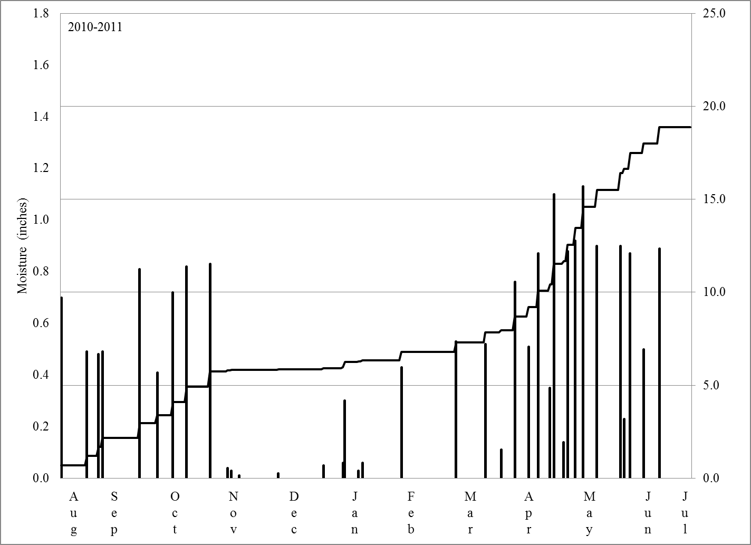
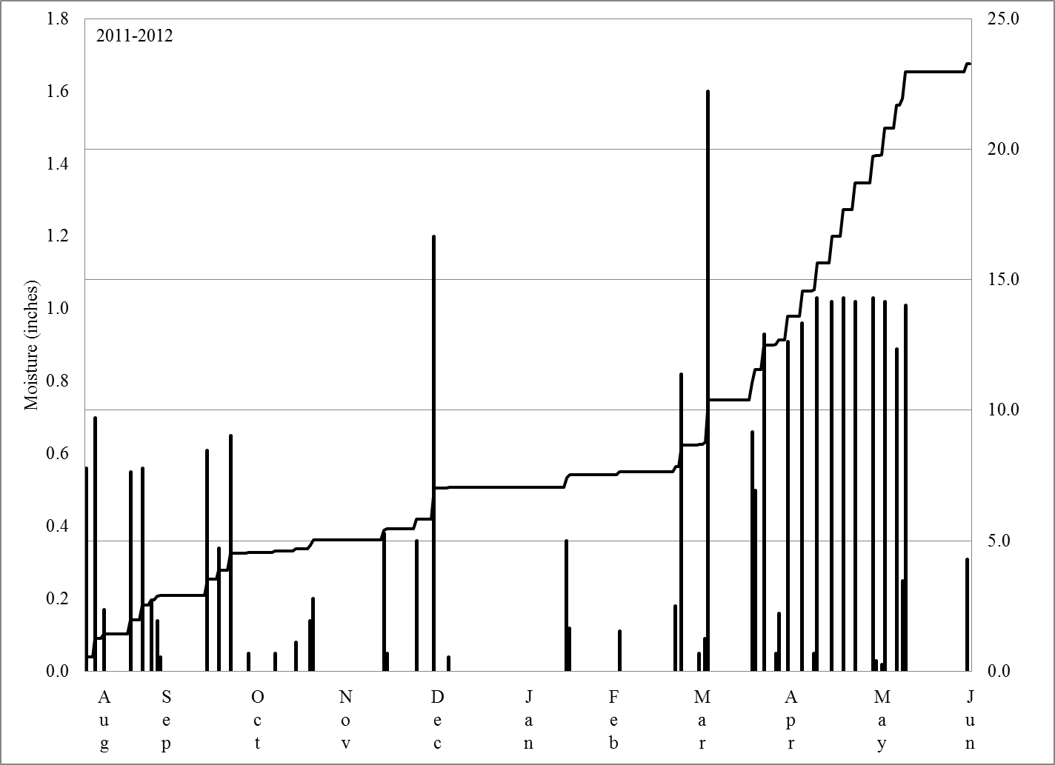
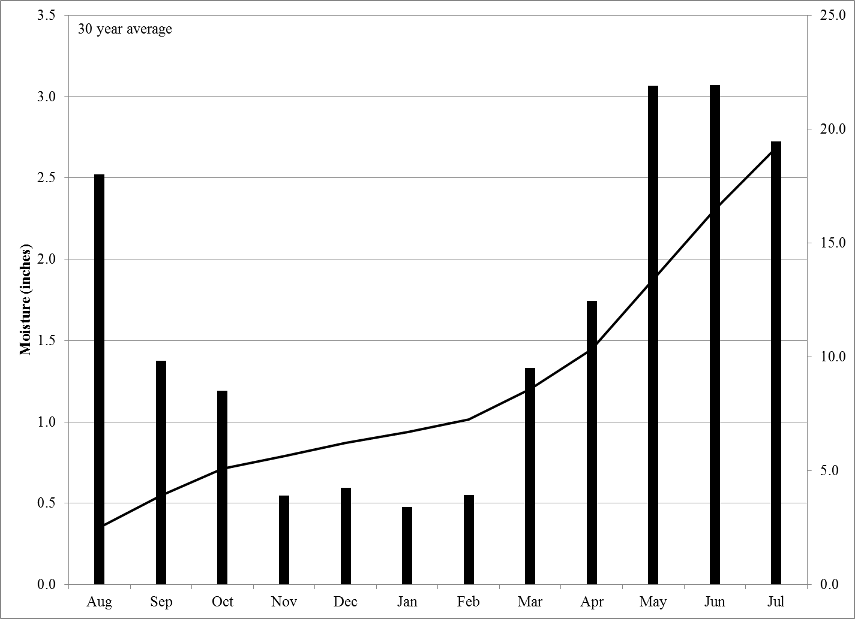

Figure 2. Maximum and minimum daily temperature between 2010 and 2012, and the maximum and minimum 30-year monthly average temperature from August through July.
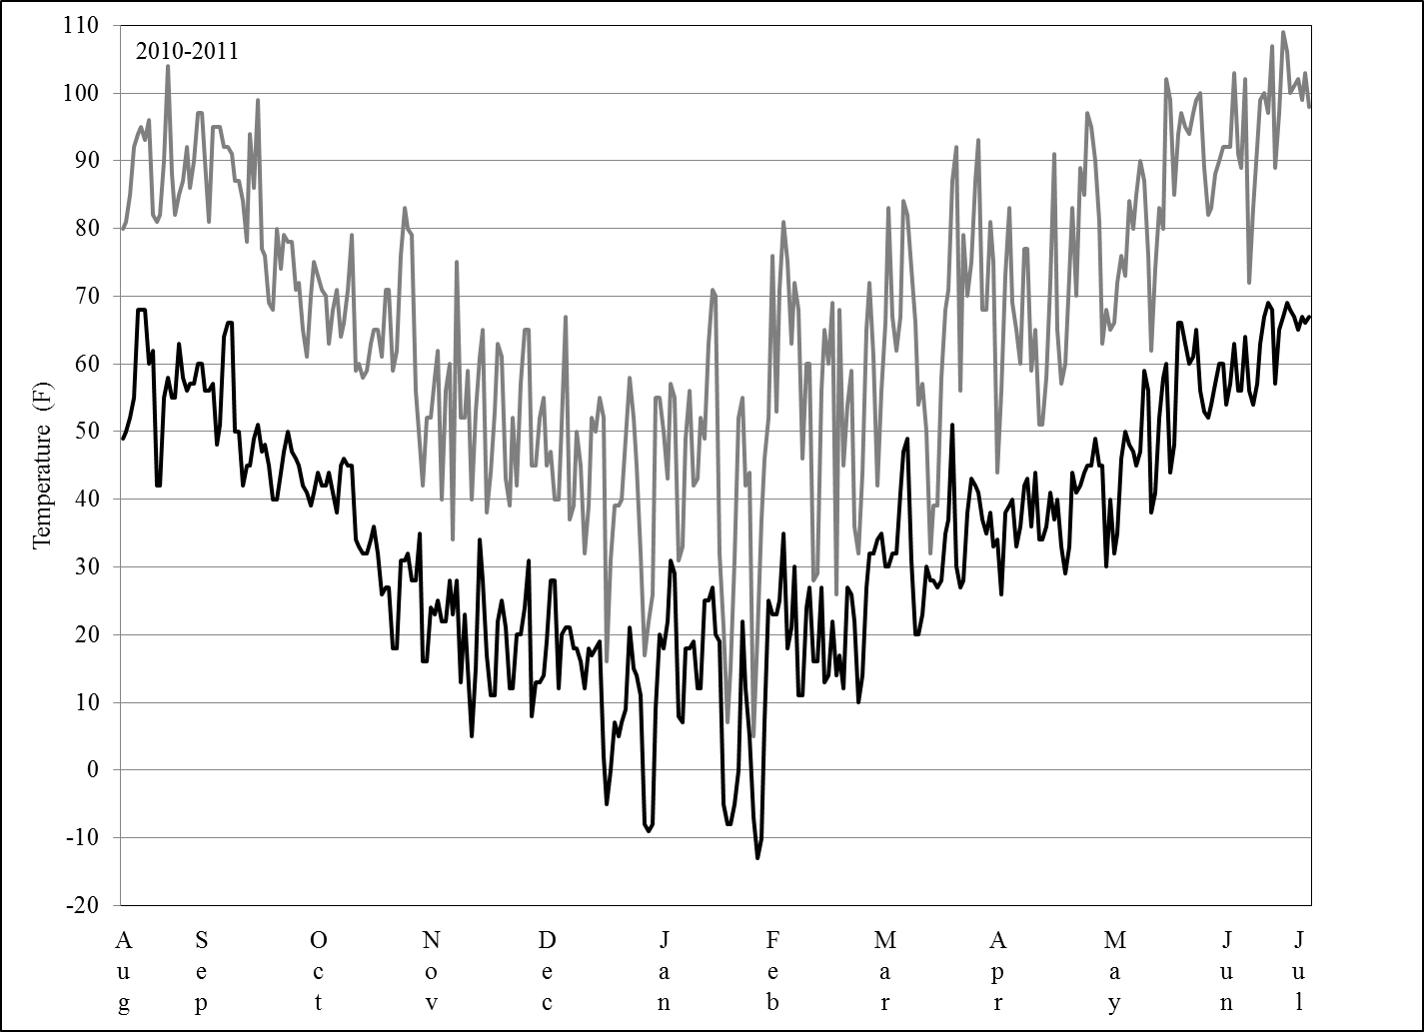
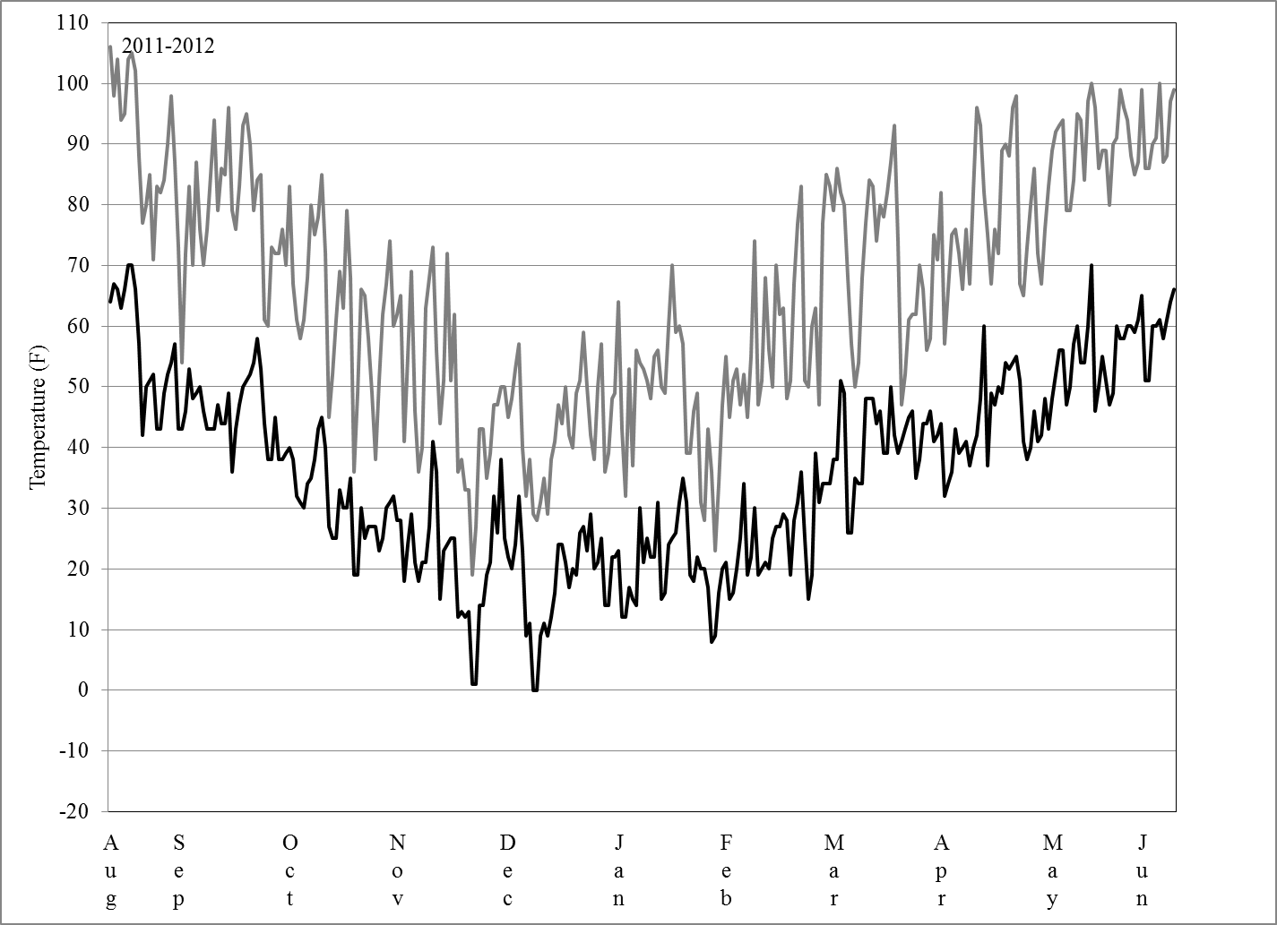
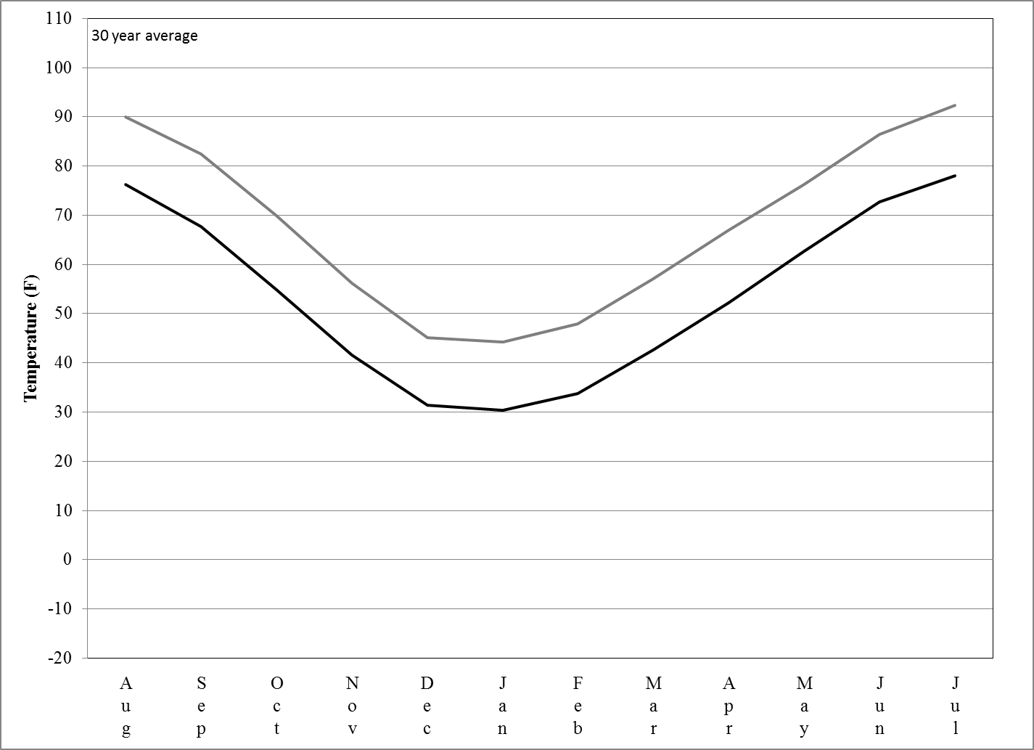

Kansas State University Department of Agronomy.

